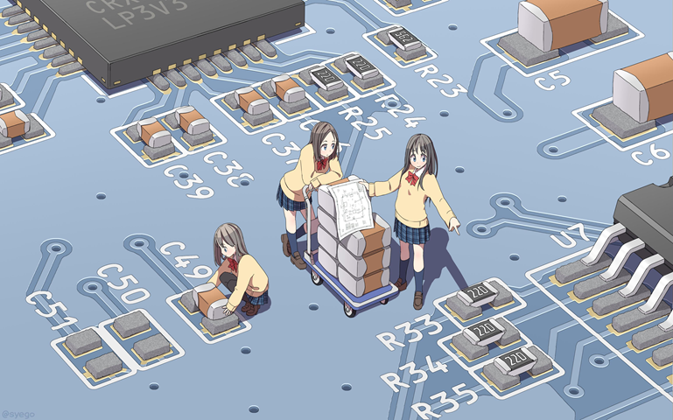

**AWS Lab #8**

**By Diego Santos**

**Intro**

Today We’ll be doing Secure Shell into amazon EC2

**Screenshots**

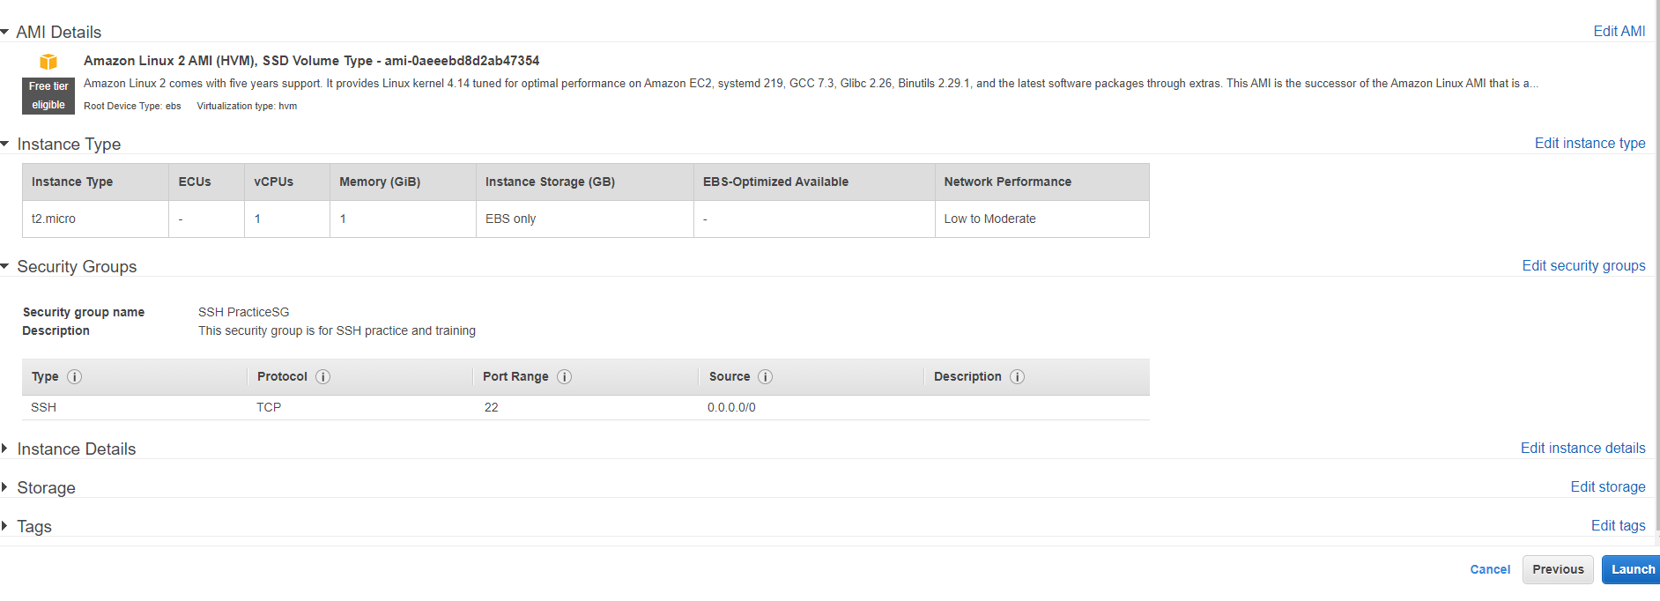

(Creating a new instance)

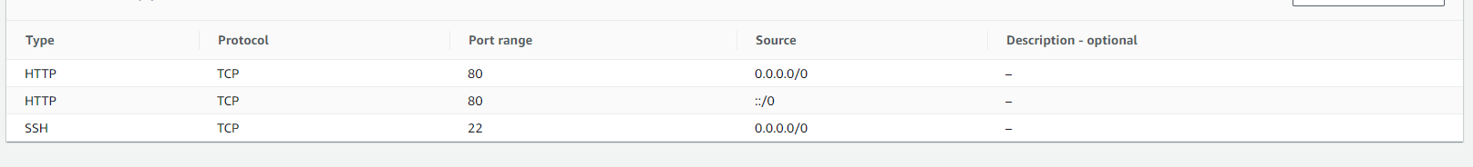

(Creating Security Rule)

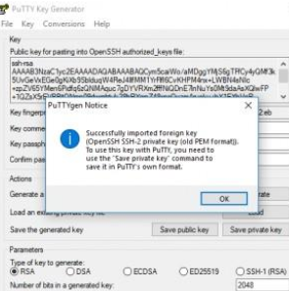  
(Importing Key)

**Problems**

I ran into no problems while setting up this lab